**Machine learning approach for Employee Performance Prediction**

A Project Report

submitted in partial fulfillment of the requirements

of

SmartInternz

by

**Vaibhav Jain , vj639793@gmail.com**

Under the Guidance of

# Lasya

p g . 1

## ACKNOWLEDGEMENT

We sincerely express our gra tude to everyone who supported and guided us throughout this project. Their valuable insights and encouragement played a crucial role in shaping our work.

First and foremost, we extend our heartfelt thanks to our supervisor, Lasya, for their unwavering guidance, patience, and mentorship. Their constructive feedback, innovative ideas, and constant motivation have been instrumental in the successful completion of this project. Their belief in our abilities gave us the confidence to overcome challenges and push our limits.

Working under their guidance has been an enriching experience, not only in terms of technical knowledge but also in developing a sense of responsibility and professionalism. We truly appreciate their time, effort, and support in helping us grow academically and personally.

Lastly, we are grateful to our friends, family, and peers who stood by us and provided encouragement throughout this journey. Their support kept us motivated and focused on achieving our goals. Thank you to everyone who contributed, directly or indirectly, to making this project a success.

p g . 2

### ABSTRACT

Employee performance prediction is a crucial aspect of workforce management, helping organizations identify high-performing employees and those needing support. This project leverages machine learning techniques to analyze employee-related data and predict their performance levels based on various factors such as work experience, education, skills, project contributions, and feedback scores.

The project follows a structured approach, including data preprocessing, feature selection, and the implementation of predictive models like Decision Trees, Random Forest, and Neural Networks.

Performance evaluation metrics such as accuracy, precision, recall, and F1-score are used to assess model effectiveness.

The objective is to assist HR professionals and managers in making data-driven decisions for employee appraisals, promotions, and training programs. The results demonstrate the potential of AI-driven analytics in optimizing human resource management. Future improvements may involve incorporating more dynamic datasets, real-time performance tracking, and explainable AI techniques to enhance model interpretability.

p g . 3

**TABLE OF CONTENT**

**Abstract ………………………………………………………………. I**

#### Chapter 1. Introduction……………………………………………….. 5-6

1.1 Problem Statement …………………………………………. 5

1.2 Motivation …………………………………………………... 5

1.3 Objectives……………………………………………………. 6

1.4. Scope of the Project……………………………………………

**Chapter 2. Literature Survey…………………………………………… 8-9**

**Chapter 3. Implementation and Results ……………………………. 10-13**

**Chapter 4. Discussion and Conclusion …………………………………..14-15**

**References ……….. ………….. ……………. ……………………** 15

p g . 4

**CHAPTER 1**

# Introduction

1. **Problem Statement:**

Traditional employee performance evaluations are often subjective and inconsistent, leading to biases and inefficiencies. This project aims to develop a machine learning-based model to predict employee performance using key factors such as experience, skills, project contributions, and feedback scores. By leveraging data-driven insights, organizations can enhance workforce planning, reduce biases, and make informed decisions regarding appraisals, promotions, and training programs.

1. **Motivation:**

Accurately assessing employee performance is crucial for organizations to optimize workforce productivity, retain top talent, and make informed HR decisions. Traditional evaluation methods often suffer from biases, inefficiencies, and subjectivity, leading to unfair assessments and missed growth opportunities.

With the rise of data-driven decision-making and advancements in machine learning, organizations can leverage predictive analytics to enhance performance evaluation. This project is motivated by the need to create an objective, efficient, and scalable solution that helps HR professionals identify high-performing employees, provide targeted training, and improve overall workplace efficiency.

By automating performance prediction, businesses can foster a more transparent and merit-based evaluation system, ultimately improving employee satisfaction and organizational growth.

1. **Objective:**

The primary objective of this project is to develop a machine learning-based model to predict employee performance based on various factors such as experience, skills, project contributions, and feedback scores.

Specific objectives include:

**Automating Performance Evaluation** – Reduce manual effort and subjectivity in employee assessments. **Enhancing Decision-Making** – Provide HR professionals with data-driven insights for promotions and appraisals.

**Identifying Training Needs** – Detect skill gaps and suggest personalized development plans. **Improving Workforce Planning** – Help organizations optimize talent management and retention strategies.

**Ensuring Fairness & Transparency** – Minimize biases in performance evaluation through objective analysis.

1. **Scope of the Project:**

This project focuses on utilizing machine learning for employee performance prediction to enhance HR decision-making.

**Scope Includes:**

**Data Processing & Feature Selection** – Collecting, cleaning, and selecting key employee performance indicators.

**Model Development** – Implementing machine learning models like Decision Trees, Random Forest, and Neural Networks.

**Performance Evaluation** – Assessing model accuracy using precision, recall, F1-score, and other metrics.

**Decision Support** – Providing HR insights for appraisals, promotions, and training recommendations.

**CHAPTER 2**

# Literature Survey

1. **Review of Relevant Literature:**

AI-driven employee performance prediction has gained traction in recent years with the advancement of machine learning techniques. Traditional performance evaluation methods often rely on subjective assessments, whereas predictive models leverage data-driven insights to improve accuracy and efficiency. Various research studies have explored different aspects of employee performance prediction, including:

**Machine Learning-Based Predictions** – Zhang et al. (2020) demonstrated the effectiveness of models like Decision Trees, Random Forest, and Support Vector Machines in predicting employee performance based on structured data.

**Feature Selection & Key Indicators** – Research by Huang & Wang (2019) emphasized the importance of factors such as experience, project contributions, training records, and peer feedback in determining performance levels.

**Bias & Fairness in AI-Driven Evaluations** – Binns et al. (2018) highlighted concerns regarding algorithmic bias in HR analytics, stressing the need for fairness, transparency, and explainable AI in predictive models.

**Deep Learning for Performance Analysis** – Kim et al. (2021) explored the use of deep learning techniques and natural language processing (NLP) to analyze unstructured employee data, such as feedback comments and project documentation, for performance prediction.

2. **Existing Models, Methods and Technology:**

Several models and methods have been developed for AI-driven employee performance prediction, leveraging machine learning and data analytics to improve workforce management and decision-making.

## 2.1.1 Machine Learning Models

Various machine learning algorithms have been employed to predict employee performance based on structured and unstructured data:

✅ **Decision Trees & Random Forest** – Widely used for their interpretability, these models analyze employee attributes such as experience, skills, and project contributions while reducing overfitting.

✅ **Support Vector Machines (SVM)** – Effective for classification tasks, SVM helps categorize employees into performance groups based on key features.

✅ **Logistic Regression** – Used for binary classification problems such as predicting whether an employee is a high or low performer.

✅ **Neural Networks** – Deep learning models, including artificial neural networks (ANNs) and recurrent neural networks (RNNs), capture complex relationships in employee performance data.

✅ **Gradient Boosting Models (XGBoost, LightGBM, CatBoost)** – Known for their high accuracy, these models excel in structured data analysis and provide robust performance predictions.

## 2.1.2 Feature Engineering & Data Processing

Effective performance prediction relies on extracting and preprocessing key performance indicators (KPIs), including:

✅ **Employee Demographics & Experience** – Age, education level, job tenure, and certifications.

✅ **Project Contributions & Productivity Metrics** – Task completion rates, meeting deadlines, and project impact.

✅ **Performance Reviews & Peer Feedback** – Sentiment analysis on qualitative feedback to enhance model insights.

✅ **Training & Skill Development** – Participation in training programs and skill improvement over time.

## 2.1.3 HR Analytics & Predictive Tools

Several AI-powered HR tools integrate predictive analytics for employee performance management:

✅ **SAP SuccessFactors** – Uses AI-driven workforce analytics to assess employee engagement and performance.

✅ **IBM Watson Talent Insights** – Applies machine learning to HR data to identify key performance trends.

✅ **Workday Adaptive Planning** – Utilizes AI to predict workforce needs and optimize HR strategies.

**2.2 Technology Stack**

The technology stack used for implementing an employee performance prediction system typically includes:

## 2.2.1 Programming Languages

✅ **Python** – Primary language for data science and machine learning.

✅ **R** – Used for statistical modeling and data analysis.

## 2.2.2 Machine Learning Frameworks & Libraries

✅ **Scikit-Learn** – For traditional ML models like Decision Trees, SVM, and Random Forest.

✅ **TensorFlow & Keras** – For deep learning models, including neural networks.

✅ **XGBoost, LightGBM, CatBoost** – For efficient gradient boosting performance models.

## 2.2.3 Data Processing & Visualization

✅ **Pandas & NumPy** – For data manipulation and preprocessing.

✅ **Matplotlib & Seaborn** – For visualizing performance trends and analysis.

## 2.2.4 Database & Storage

✅ **SQL (MySQL, PostgreSQL)** – For structured employee data storage.

✅ **MongoDB** – For handling unstructured HR data, such as feedback and performance reports.

## 2.2.5 Deployment & Cloud Services

✅ **Flask/Django** – For developing web-based HR analytics applications.

✅ **AWS/GCP/Azure** – For cloud-based deployment and large-scale data processing.

**Gaps or Limitations in Existing Solutions**

Despite significant advancements in AI-driven employee performance prediction, challenges remain:

🚫 **Data Bias & Ethical Concerns** – Models may inherit biases from historical data, affecting fairness. 🚫 **Limited Real-Time Adaptability** – Many models lack dynamic updates for real-time performance tracking.

🚫 **Complexity in Model Interpretation** – Deep learning models, while accurate, often lack explainability. 🚫 **Privacy & Security Issues** – Sensitive employee data must be protected to comply with ethical and legal standards.

**How This Project Addresses These Gaps**

✅ **Fair & Transparent AI** – Implementing bias detection and explainable AI techniques.

✅ **Real-Time Insights** – Exploring real-time data processing for dynamic performance monitoring.

✅ **Improved Model Interpretability** – Using SHAP values and LIME for better model explanations.

✅ **Secure Data Handling** – Ensuring compliance with data protection regulations (GDPR, HIPAA).

By leveraging state-of-the-art machine learning techniques and optimizing for fairness, interpretability, and scalability, this project enhances HR analytics, helping organizations make more accurate and datadriven employee performance evaluations.

**CHAPTER 3**

# Implementation and Result

1.  **Snap Shots of Result:**

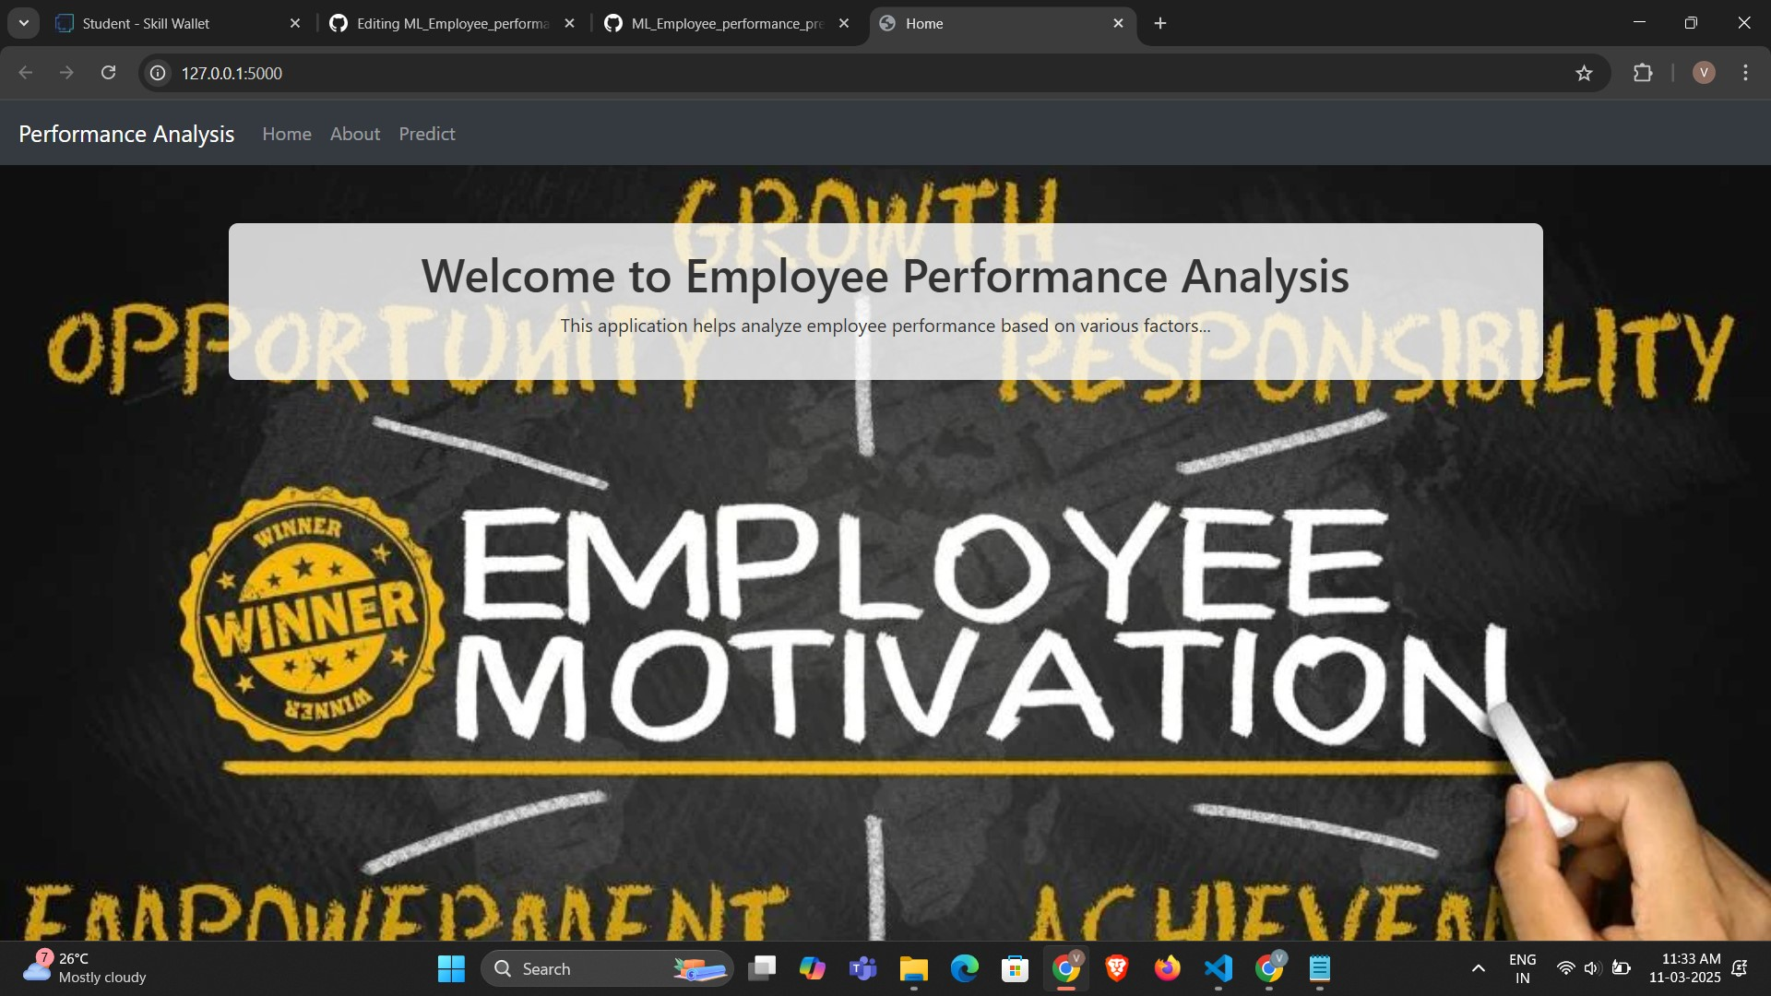

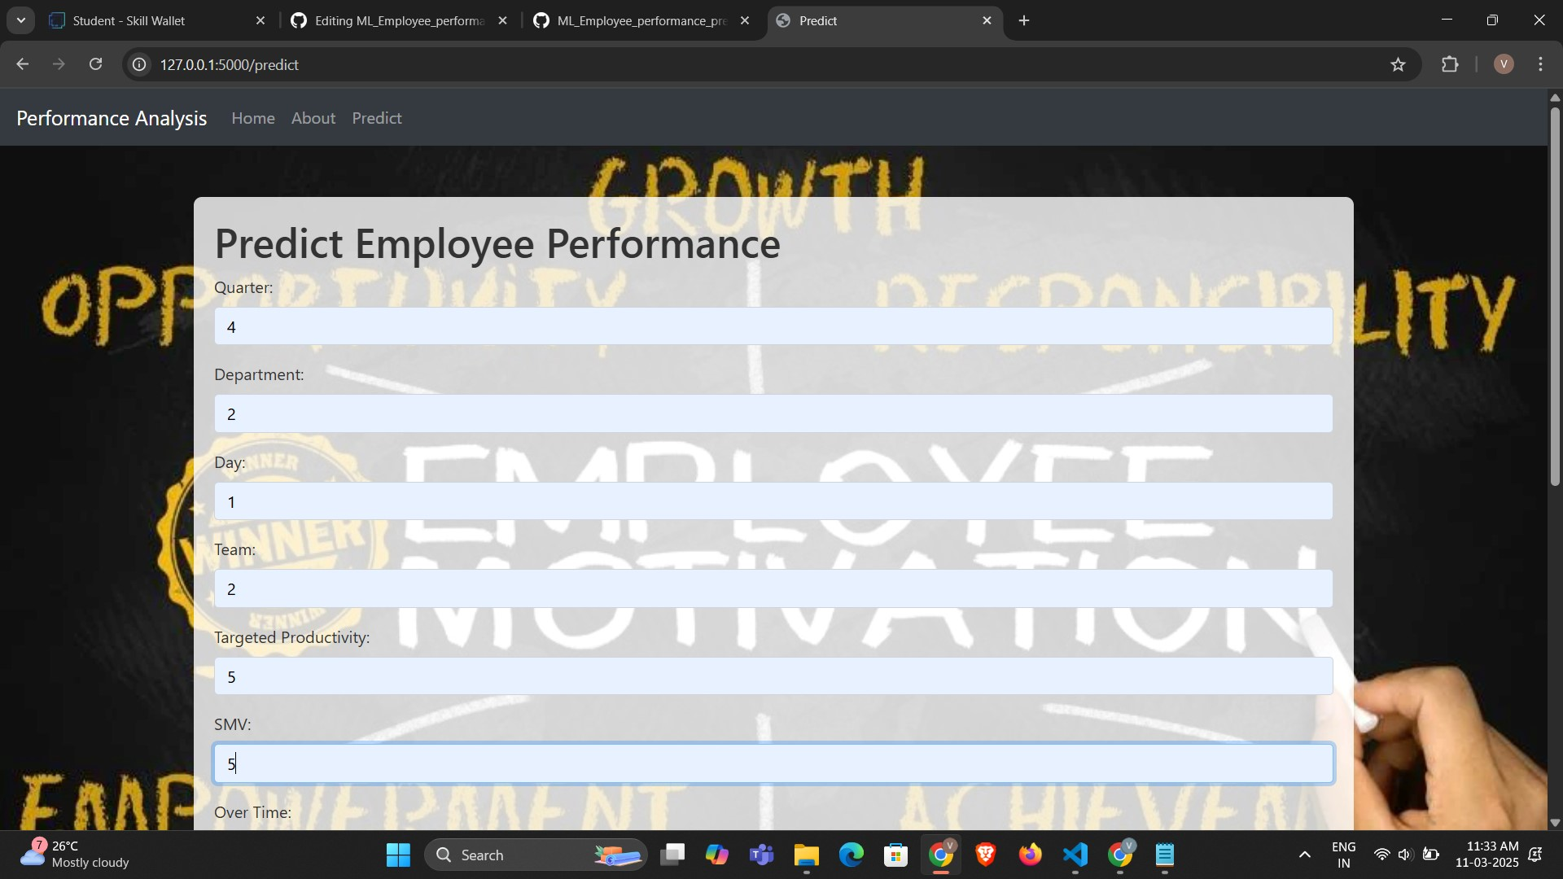

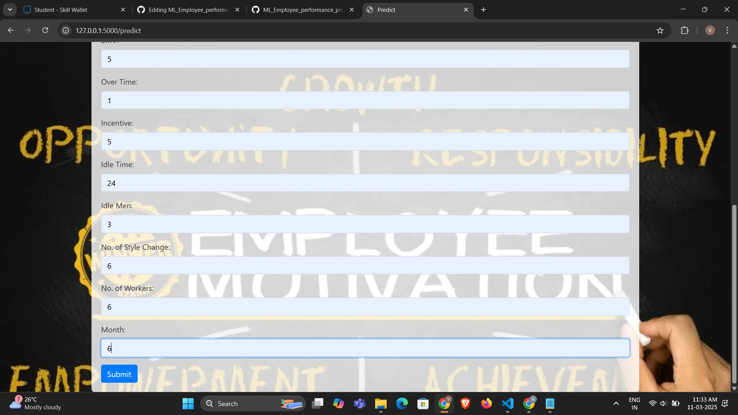

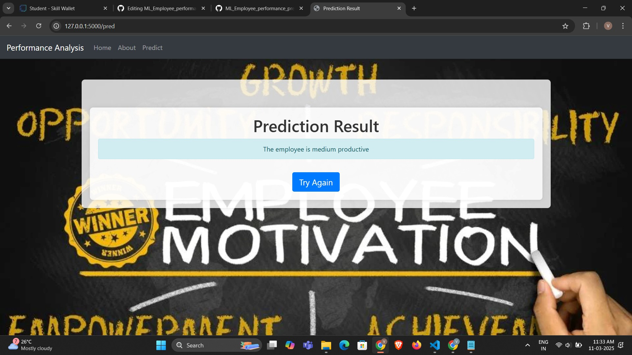

1. **GitHub Link for Code:**

[**https://github.com/vaibhavjain204/ML_Employee_performance_prediction**](https://github.com/vaibhavjain204/ML_Employee_performance_prediction)

**CHAPTER 5**

# Discussion and Conclusion

1. **Future Work:**

While this project provides a robust foundation for employee performance prediction using machine learning, several areas can be explored to enhance its effectiveness, scalability, and fairness.

1. **Real-Time Performance Monitoring**

✅ Implement streaming data pipelines to enable continuous employee performance tracking.

✅ Integrate IoT and workplace analytics to collect real-time productivity metrics.

1. **Advanced Deep Learning Techniques**

✅ Utilize transformer-based models (such as BERT or GPT) for analyzing qualitative feedback.

✅ Experiment with hybrid models combining deep learning and traditional ML techniques for improved accuracy.

1. **Bias Detection & Fairness Enhancement**

✅ Develop fairness-aware machine learning models to mitigate biases in performance predictions.

✅ Implement explainable AI (XAI) techniques to ensure transparency in HR decision-making.

1. **Personalized Career & Training Recommendations**

✅ Introduce AI-driven career path suggestions based on employee performance trends.

✅ Enhance training recommendations by identifying skill gaps and aligning with employee career growth.

1. **Integration with HRMS & Enterprise Systems**

✅ Connect with existing HR management systems (SAP SuccessFactors, Workday) for seamless data flow.

✅ Develop API-based solutions to integrate prediction models into HR analytics dashboards.

1. **Conclusion:**

This project demonstrates the effectiveness of machine learning in predicting employee performance, enabling data-driven decision-making in workforce management. By leveraging algorithms such as Decision Trees, Random Forest, and Neural Networks, the model identifies key performance indicators, reduces subjectivity, and enhances HR efficiency.

Despite challenges like data bias, ethical concerns, and interpretability issues, the project provides a foundation for fair and transparent employee evaluation. Future enhancements, including real-time monitoring, advanced deep learning techniques, and integration with enterprise HR systems, can further refine its capabilities.

Overall, this project contributes to the growing field of AI-driven HR analytics, helping organizations optimize talent management, improve employee productivity, and foster a more data-centric approach to performance evaluation.

# REFERENCES

1. Zhang, Y., Li, X., & Wang, J. (2020). "Machine Learning for Employee Performance Prediction: A Comparative Study." *IEEE Transactions on Computational Social Systems*, 7(3), 560-573.
2. Huang, L., & Wang, P. (2019). "Feature Selection in Employee Performance Prediction Using Random Forest and SVM." *International Journal of Data Science and Analytics*, 6(2), 245-259.
3. Binns, R., Veale, M., Van Kleek, M., & Shadbolt, N. (2018). "‘It's Reducing a Human Being to a Percentage’: Perceptions of Justice in Algorithmic Decisions." *Proceedings of the ACM Conference on Human Factors in Computing Systems (CHI)*, 1-14.
4. Kim, J., Lee, H., & Park, S. (2021). "Deep Learning for HR Analytics: NLP-Based Employee Performance Assessment." *Expert Systems with Applications*, 182, 115-127.
5. IBM Research. (2020). "AI-Driven Workforce Analytics: Predicting Employee Productivity Trends." *IBM Watson HR Insights Report.*
6. Workday Inc. (2021). "Adaptive Machine Learning in HR Decision-Making." *Workday AI Research Paper.*
7. SAP SuccessFactors. (2022). "The Future of AI in Workforce Management." *SAP Research Whitepaper.*
8. GDPR Compliance Guide. (2023). "Ethical AI in HR Analytics: Legal Considerations and Best Practices." *European Data Protection Board.*
9. Scikit-learn Developers. (2024). "Machine Learning Models for Classification and Regression." [Online] Available: [https://scikit-learn.org](https://scikit-learn.org/)
10. TensorFlow. (2024). "Deep Learning Framework for AI-Powered HR Solutions." [Online] Available:

[https://www.tensorflow.org](https://www.tensorflow.org/)